

## Faculty Of Engineering & Technology

A report on

**SOLAR TRACKERING SYSTEM**

Under of subject

Design Of Mechatronics-N

Supervised By

DR.Abdelaziz Hussien

By Teaching Assistant

Eng. Mahmoud Dardery

Eng. Nada Anwer

Academic Year

(2023-2024)

* List of students :
  + Bahaa Adel (202021404)
  + Bassent Mohamed (20204863)
  + Islam Nagi (20207327)
  + Mohamed Foad (202021374)
  + Omar Khaled (2022006780)
  + Waled Magdy (20202123)

Acknowledgement

We would like to express our heartfelt gratitude to **Dr.Abdelaziz**, who is your supervisor , for her constant guidance

and helping in the implementation of this project.

We must particularly thank he for commitment and unrelenting effort to see us do all the assignments appertaining

to this project and finally we can say we had done.

We would also like to thank the workshop technicians for their cooperation and support during material collection

and also during our project. All your sup

We would like special thanks to the Dean of the College of Engineering **Dr. Arif**, and the Head of the Mechanical Departmen **Dr. Jamal**, for the support and approval to use the college’s workshops and resources.

Thank you all.

Abstract

A project aims to design and implement a solar tracking system that operates in dual-axis, enabling the solar panels

to efficiently follow the sun's movement throughout the day. The solar tracking system utilizes sensors to detect the

sun's position and move the solar panels accordingly to maximize sunlight exposure. The dual-axis tracking ensures

that the solar panels are always oriented perpendicularly to the sun, increasing the overall energy output of the solar

power system. The project will focus on the design and construction of the tracking mechanism, the implementation

of control algorithms, and the performance evaluation of the dual-axis solar tracking system. Potential benefits of

this project include increased energy generation, improved efficiency, and a more sustainable renewable energy

solution for various applications.

Content

* Chapter 1 : **………………………………………………………….7-9**

1.1 Introduction……………………………………………………………

* 1. Problem Statement………………………………………………..
  2. Project Objective……………………………………………………
  3. Methodology…………………………………………………………
  4. Tasks…………………………………………………………………….
* Chapter 2 : **………………………………………………………. 10-12**

## 2.1 Introduction …………………………………………………………………

### 2.1.1 Types of Solar Trackers and Solar Tracking Techniques….

### 2.1.2 Single Axis Solar Tracking System……………………………………

### 2.1.3 Dual Axis Solar Tracking System…………………………………….

### 2.1.4 Active Solar Tracking……………………………………………………..

### 2.1.5 Passive Solar Tracking ………………………………………………….

### 2.1.6 Review of Solar Tracking Methods……………………………….

## 2.2 A Review of Solar Tracking Methods……………………………….

### 2.2.1 Introduction………………………………………………………………..

### 2.2.2 Solar Tracking in Relation to Rotation and Revolution of the Earth….

### 2.2.3 Nature of Solar Irradiation and the Solar Constant ……………………

### 2.2.4 Sunlight…………………………………………………………………………

### 2.2.5 The Solar Constant……………………………………………

### 2.2.6 Fixed and Tracking Collectors …………………………..

### 2.2.7 Fixed Collectors………………………………………………….

### 2.2.8 Tracking Collectors: Improved Efficiency…………………..

* Chapter 3: **………………………………………………………… 13-27**
  1. Design ………………………………………………………..
  2. Mathmatical ……………………………………………….
     1. motors………………………………………………….
     2. Solar panel ……………………………………………..
  3. Electrical Design ………………………………………….29

3.3.1 Circuit ………………………………………………………..29

* 1. Simulink ………………………………………………………
* Chapter 5: **………………………………………………………… 29-50**

5.1 Flow chart ……………………………………………………………..

5.2 Block digram………………………………………………………….

# Chapter 6:………………………………………………………..

## 5.1 Advantages And Disadvanates…………………………..

# CHAPTER 7:

## 6.1 SCOPE OF IMPROVEMENT……………………………………………..

### 6.1.1 Future Work and Recommendations………….

# CHPATER 8:

## References…………………………………………………………

## Abbreviations And Acronyms…………………………….

* Conclusion **………………………………………………………. 51**
* Apendix **………………………………………………………….. 52-65**

-Components

- Data sheet

|  |  |  |
| --- | --- | --- |
| Figure.no | Figure description | Page no : |
| 1 | Single Axis Solar Tracking System | 11 |
| 2 | Dual Axis Solar Tracking System | 12 |
| 3 | sun path in pune | 14 |
| 4 | sun path in pune | 14 |
| 5 | . *path part 1* | 17 |
| 6 | . *path part 2* | 17 |
| 7 | . *path part 3* | 19 |
| 8 | . *path part 4* | 19 |
| 9 | . *path part 5* | 20 |
| 10 | . *path part 6* | 20 |
| 11 | . *path part 7* | 21 |
| 12 | The distance between the center of rotation and the center of gravity | 24 |
| 13 | Total inertia seen by the motor 1 shaft | 25 |
| 14 | Figure 14 solar panal | 34 |
| 115 | end project | 67 |

##### INTRUDUCTION:

##### Today's world has increasing demands for energy by the day, which is against the continuous reduction in existing resources of fossil fuels and ever growing concern regarding environmental pollution. It's therefore needless to say that this has pushed mankind to explore new technologies for production of electrical energy, using clean, renewable sources such as solar and wind power. A prominent non-conventional renewable energy source is solar energy which provides great prospect for conversion into electrical power, which in turn ensures an important part of the electrical energy needs of the planet. Photovoltaic (PV for short) is the conversion principle employed in conversion of solar light into electricity. Using solar tracking technique, yield from solar panel can be increased by 30%-60% unlike in stationary or fixed installations which if we assume silicon is the material used to build the PV panels, then the system is only about 24.5% efficient

##### problem statement :

The problem statement of solar trackers revolves around addressing challenges and limitations in their design, implementation, and performance. Common issues include reliability and maintenance concerns, cost-effectiveness compared to fixed-tilt systems, complexity and installation challenges, environmental impacts, scalability and adaptability to different conditions, and integration with grid infrastructure and energy management systems. Addressing these challenges is crucial for enhancing the efficiency, reliability, and economic viability of solar tracking technology.

##### project objective :

The primary objective of a solar tracker project is to maximize the efficiency of solar panels by orienting them towards the sun throughout the day, ensuring they capture as much sunlight as possible. This helps to increase energy production and improve the overall performance of solar power systems.

Solar tracking can be a crucial element in improving the efficiency of solar energy systems. When solar panels are directly facing the sun, they receive maximum sunlight radiation. However, the position of the sun moves across the sky throughout the day and seasons, so maintaining optimal orientation of solar panels towards the sun continuously is necessary to ensure maximum efficiency. This is where solar tracking systems come into play.

Solar tracking can be done using various techniques, including mechanical, single-axis, dual-axis, and geographical-dependent systems, depending on the project's geographical location. Tracking techniques help increase the productivity of solar panels by around 20% to 30% compared to fixed panels.

In addition to increasing productivity, solar tracking can reduce the overall costs of solar energy by enhancing efficiency, reducing the number of panels required to generate the same energy, thus lowering the total project cost.

Overall, solar tracking enhances the overall performance and economic efficiency of solar energy systems, making it a lucrative option for both investors and consumers alike.

##### methodology:

The methodology for implementing a solar tracking system typically involves several steps:

1. Research and Planning:* Understand the location's solar resource potential, including sun path and intensity variations throughout the day and seasons. Determine the optimal tracking technology based on factors like project size, budget, and available space.
2. *System Design:* Design the solar tracking system layout, considering factors such as the number of axes (single-axis or dual-axis), tracking mechanism (mechanical or electronic), and structural support requirements.
3. *Component Selection:* Select appropriate components such as tracking sensors, actuators, controllers, and mounting hardware based on the chosen design and environmental conditions.
4. *Installation:* Physically install the solar tracking system according to the designed layout, ensuring proper alignment and structural integrity. This may involve excavation, foundation pouring, and assembly of tracking structures.
5. *Wiring and Integration:* Connect the tracking system components, including sensors, actuators, and controllers, and integrate them with the solar panels and power generation system.
6. *Testing and Calibration:* Test the tracking system to ensure proper functionality and alignment with the sun's position. Calibrate sensors and controllers as needed to optimize tracking accuracy and efficiency.
7. *Monitoring and Maintenance:* Implement a monitoring system to track the performance of the solar tracking system and identify any issues or malfunctions. Perform regular maintenance tasks such as cleaning, lubrication, and adjustment to ensure optimal operation and longevity of the system.

##### taskes :

* + The tasks were distributed to the group members as shown:

2-Bahaa Adel (Mathmatical Modling )

2-Bassent Mohamed (Matlab Simulatio)

3-Islam Nagi (report , codeing)

4-Mohamed Foad (report , Assembling parts)

5-Omar Khaled (Electronics Modeling)

6-Waled Magdy (design S.W)

## chapter 2

**2.1 Introduction**

Among the renewable energy sources is electrical solar energy from the Sun can be harnessed using solar panels or solar cells to convert solar irradiation into electrical current. Most photovoltaic cells employ photoelectric effect. This is a process by which electrons are emitted from some materials, such as a metal, as a result of being struck by photons. Some substances, such as selenium, are particularly susceptible to this effect and if used in solar cells, they can generate some electric potential through photoemission.

Sun rays come in form of UV-light, a form of electromagnetic radiation and once they fall of solar panel surface made of materials such as silicon, the irradiation is absorbed and converted into electrical energy through photo emission. Maximum absorption occurs when the solar panels and solar cells directly face the Sun, so that the sun's rays fall perpendicularly on the absorption surface.

This absorption and conversion may not be optimal given that the solar panels and solar cells are mounted in fixed positions usually on rooftops with slants. For viable solar energy generation using single installation, its efficiency has to be improved and therefore various solar tracking methods are devised to closely track sun movement during the day.

**2.2 Types of Solar Trackers and Solar Tracking Techniques**

Modern solar tracking methods can be classified into the following categories: 2.2.1: Single Axis Solar Tracking System This is method is usually used for solar trackers aimed to be used in the tropics where the focus is to track the angle of altitude (angle of tilt) of the sun along a single axis. A single linear actuator is used, such as a motor to drive the panel according to sun movements. A set of two LDRs on opposite sides of the solar panel may be used to measure the intensity of the solar irradiation by measuring the voltage drop across them which is then compared by a drive circuit until the two LDR voltages are equal and the motion of the panel is stopped. This way, the solar panel is always oriented, normally to sun irradiation

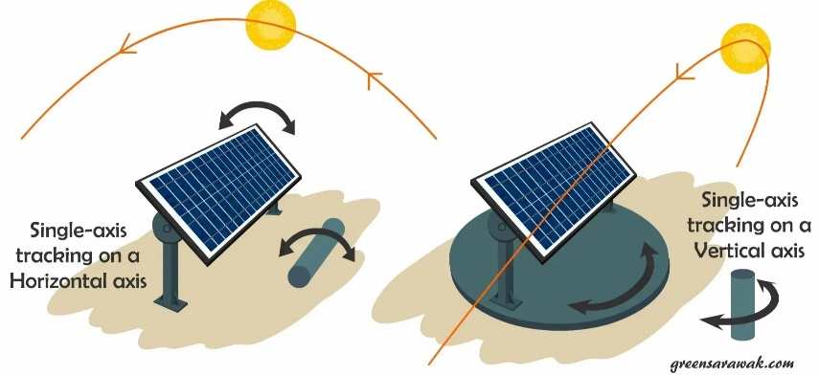

Figure 1 Single Axis Solar Tracking System

**2.2.2: Dual Axis Solar Tracking System**

This method is mainly designed for localities outside the tropics or areas beyond 10°N and 10°S of Equator. In this technique, both angle of azimuth and angle of Tilt of the solar tracker are used to track the sun movements throughout the year. Consequently, a set of two actuators, usually motors is used to move the solar panel accordingly by receiving voltage control signals from a set of four LDRs (two on opposite sides of solar panel) and when the voltage drop on all the four LDRs is equal then the panel is experiencing the maximum solar irradiation and therefore the motion stops. This ensures the solar panel is at right angles with sunlight at all times

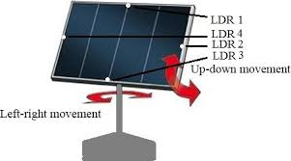

Figure 2 Dual Axis Solar Tracking System

**2.2.3: Active Solar Tracking**

This technique involves the continuous and constant monitoring of the sun's position throughout daytime and when tracker is subjected to darkness it stops or sleeps according to its design. This can be done using of light sensitive sensors, such as photo resistors (LDRs) whose voltage output are input into a microcontroller which then drive actuators (motors) to adjust the solar panels position.

**2.2.4: Passive Solar Tracking**

This method involves trackers that determine the Sun's position by means of a pressure imbalance created at two ends of the tracker. This imbalance is caused by solar heat creating gas pressure on a low boiling point compressed gas fluid that is driven to one side or the other which then moves the structure.

**2.3 A Review of Solar Tracking Methods**

**2.3.1: Introduction**

As stated above, there is an urgent need for better solar tracking technologies to be developed to harness vast amounts of electrical solar energy in large scale to cater for the ever growing power demand. Of concern too is the reduction in the environmental pollution due to use of fossil based fuels. To construct a cost effective, efficient and effective solar tracking system, it is necessary to understand the rotation and revolution of the Earth with respect to the locality in question so as to know the specification of the solar tracker to be constructed. Since any solar tracker follows the motion of the sun in the sky, it is very necessary to understand rotation & revolution of the. Earth, solar irradiation and efficiency of tracking systems which will be shown in later in this project.

**2.3.2: Solar Tracking in Relation to Rotation and Revolution of the Earth**

The Earth rotates about its own axis taking 24 hours to complete one rotation of 360 degrees and at the same time it revolves around the sun in a year of 365% days or 366 in a leap year. Revolution takes place in an elliptical orbit called the ecliptic. In addition to the revolution of the. Earth, it is observed that the relative position of the midday Sun at different times of the year varies. The inclination of the sun from the earth is referred to as the solar altitude angle. This is the vertical angle between the projection of Sun's rays on the horizontal plane and direction of sun's rays passing through the point. Usually this is estimated to be a decline of 23% degrees northwards and southwards, in one complete revolution about the Sun. The Earth also has an axial tilt of about 23.4". The altitude of the sun can also be explained by use of solar zenith angle (@z) which is a vertical angle between Sun's rays and a line perpendicular to the horizontal plane through the point (8 2 =90a). Solar azimuth angle (ys) is the horizontal angle measured from south (in the northern hemisphere) to the horizontal projection of the Sun's rays.

**2.4 Nature of Solar Irradiation and the Solar Constant**

Sunlight contains UV light which is a solar radiation in form of an electromagnetic radiation given off by the Sun. Resulting from the intense temperature and pressure at the core of the Sun, solar fusion takes place. Protons are converted into helium atoms at a rate of 600 million tons per second. Since the output of this process has lower energy than the protons that began, the fusion gives off a tremendous amount of energy in the form of gamma rays. These gamma rays are absorbed by particles in the Sun, and then re-emitted. Over the course of 200,000 years, photons of light make their journey through the radiation zone of the Sun. Solar irradiation is the measure of the total incident solar radiation transmitted to the surface of the Earth's atmosphere in a given unit of time. Solar radiation from the. Sun can be direct, diffuse nor reflected. Direct radiation, also called beam radiation, is the solar radiation travelling on a straight line from the sun down to the surface of the Earth. Diffuse radiation refers to the sunlight that has been scattered by molecules and particles in the atmosphere but that has still made it down to the surface of the earth. Unlike direct radiation, diffuse radiation doesn't have a definite direction. Reflected radiation describes the Sunlight that has been reflected off of non-atmospheric surfaces such as the ground. The solar radiation data are usually given in the form of global radiation on a horizontal surface and solar and PV panels are usually positioned at an angle to the horizontal plane.

**2.4.1: Sunlight**

Photometry enables us determine the amount of light given off by the Sun in terms of brightness perceived by the human eye. In photometry, a luminosity function is used for the radiant power at each wavelength to give a different weight to a particular wavelength that models human brightness sensitivity. Photometric measurements began as early as the end of the 18th century resulting in many different units of measurement, some of which cannot even be converted owing to the relative meaning of brightness. However, the luminous flux (or lux) is commonly used and is the measure of the perceived power of light. Its unit, the lumen, is concisely defined as the luminous flux of light produced by a light source that emits one candela of luminous intensity over a solid angle of one steradian. The candela is the Sl unit of luminous intensity and it is the power emitted by a light source in a particular direction, weighted by a luminosity function whereas a steradian is the SI unit for a solid angle; the two-dimensional angle in three dimensional space that an object subtends at a point.

**2.4.2: The Solar Constant**

The is defined as the amount of solar energy received upon a unit surface by the Earth's atmosphere, perpendicular to the Sun's direction and is usually expressed in calories per square centimeter per minute, and in these units, common values are in the range 1.89 to 1.9cm/minute. The determination of the solar constant is facilitated by solar spectral-irradiance curves. These are obtained with a recording spectrobolometer (a combined spectroscope and bolometer for determining the wavelength distribution of radiant energy emitted by a source) and referenced to a measurement obtained from a pyrheliometer that determines the total radiation at the same time.

**2.5. Fixed and Tracking Collectors**

**2.5.1 Fixed Collectors**

Harnessing of solar energy can be done using either fixed or movable collectors. Fixed collectors are mostly mounted on the places with maximum sunlight and at relatively good angle in relation to the sun such as rooftops. The aim is to expose The panel for maximum hours in a day without necessarily involving tracking technologies and therefore a considerable reduction in installation and maintenance cost is realized. As such, majority of the collectors are fixed type. For fixed solar collectors therefore is very necessary to know the position of the sun at various seasons and time s of the year so as to give the optimum orientation of the collector during installation to give the maximum solar energy All year round. Since the focus of this project was to design a solar tracker device To be used in Nairobi, the sun chart diagram of this locality is

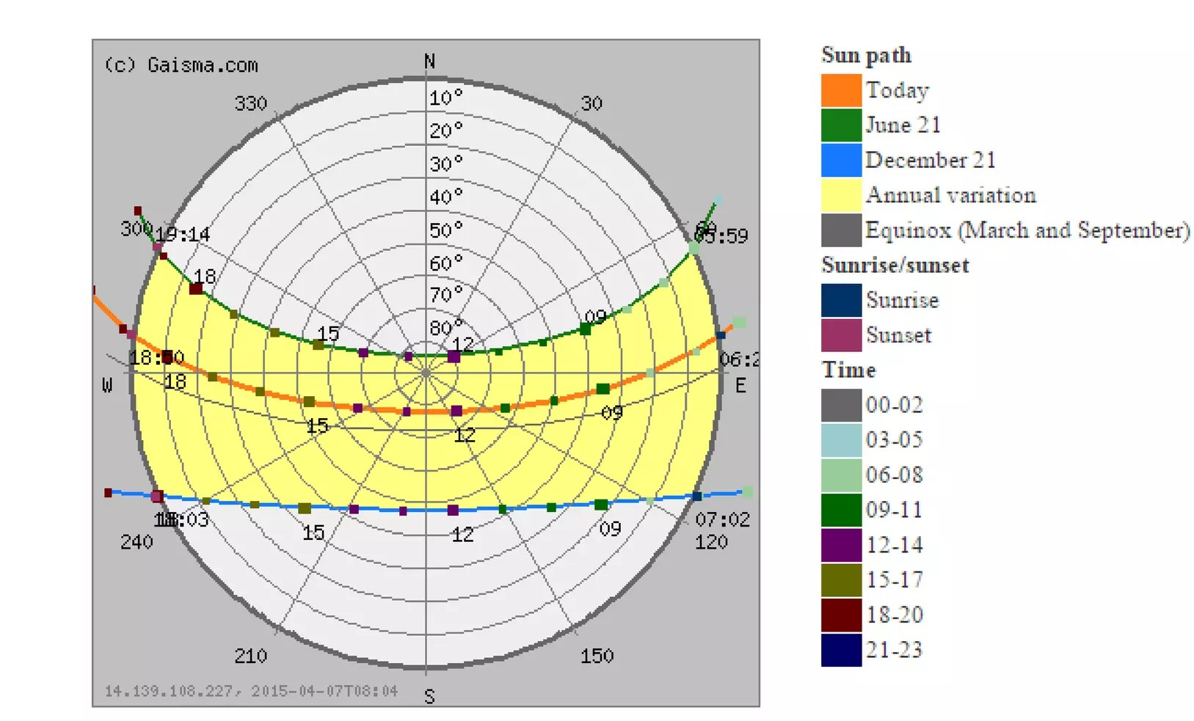

Fig 2.1 sun path in pune

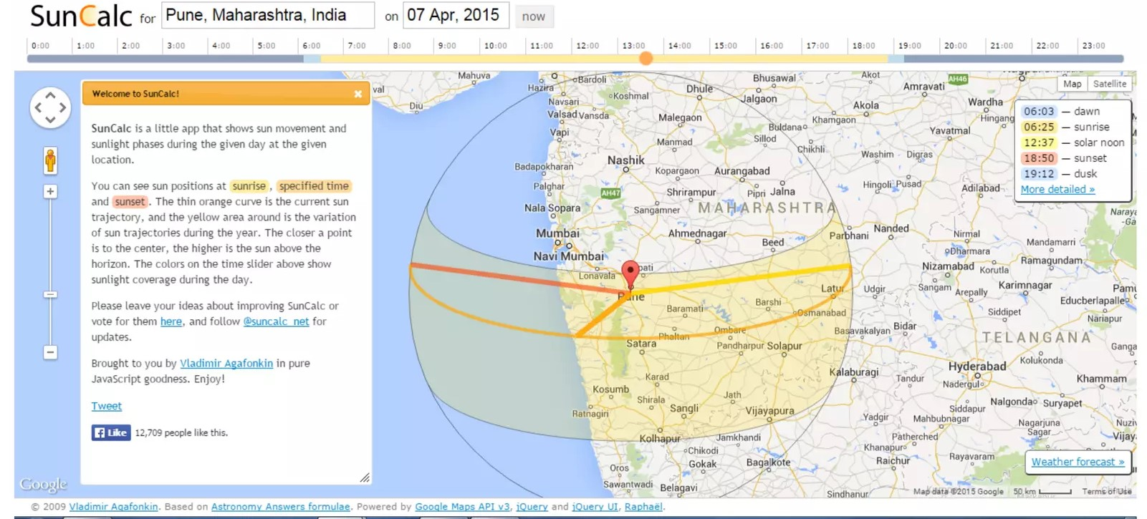

Figure 4. sun path in pune

By using this chart, we can almost definitively ascertain the position of the sun during different time and seasons of the year such that we are able to fix the payload, in this case a fixed solar panel or photovoltaic cell to give us the maximum energy output. As previously discussed, it should be noted that fixed solar trackers are cheaper and therefore more preferred around countries in the tropics region, Kenya being no exception. In fact in chapter 3, the results will be recorded and analyzed for both fixed and tracking solar panel to point out the differences in efficiency. However, for countries beyond +10degrees North and 10degrees South of Equator, there is serious need for solar tracking since th number of sunshine hour's maybe less and/or the position of the midday sun may vary significantly. As is evident from this chart, the position of the sun in the sky is highest in the period between the hours of 1200h and 1400h. For hours outside this range, the solar collectors are obliquely oriented to the Sun and as a result, only a fraction reaches the absorption surface of the solar collector since the payload cannot track sun movements.

**2.5.2: Tracking Collectors: Improved Efficiency**

For a tracking collector, the theoretical extracted energy is calculated assuming that the maximum radiation intensity I = 1100 W/m2is falling on the area which is oriented perpendicularly to the direction of radiation. Taking the length of day t = 12h 43200s, the intensity on the tracking collector which is always optimally oriented facing the Sun is compared to that of a fixed collector which is oriented perpendicularly to the direction of radiation only at noon. The collector area is marked as So.

## Chapter 3

##### Design :

Figure 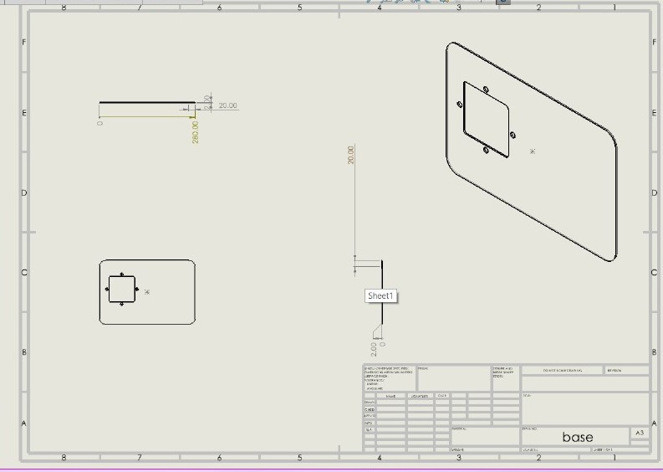5 . *path part 1*

This is the piece that we use as a base of our project which we install all the other pieces.

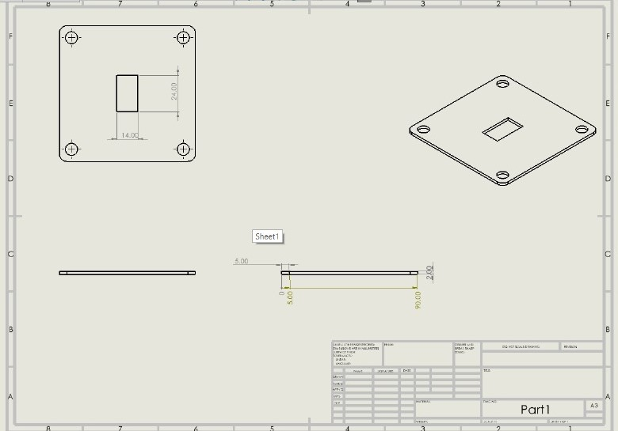

Figure 6 path part 2

This is the first part that we installed in the base and it has a servo motor that is used to rotate the

project 180 degree.

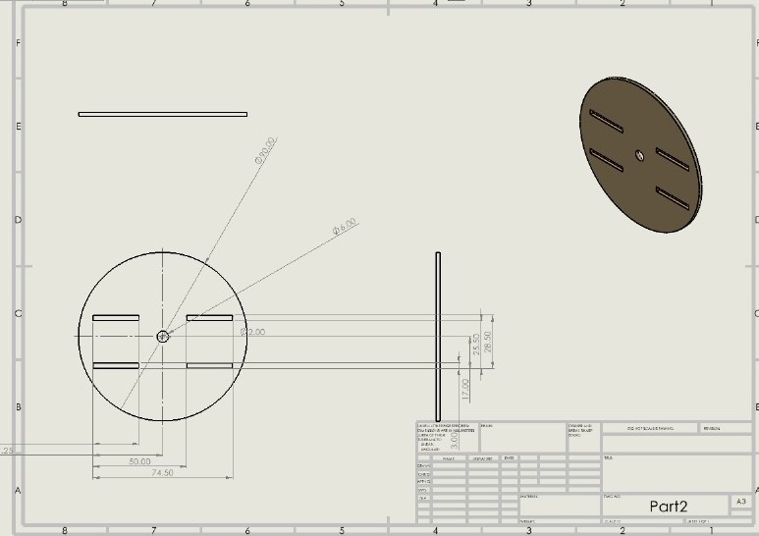

This part is the center of rotation and it is connected by servo motor of part 1.

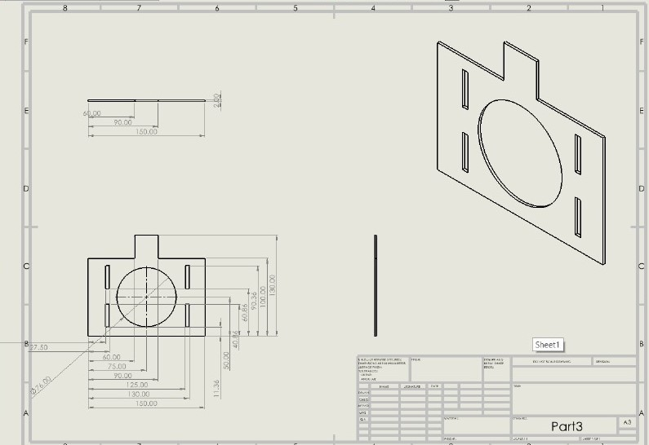

*Figure .7 path part 4*

This piece is considered the main piece in our project because it has the 2 main components of the project (4 LDR sensors – Solar panel).

Figure 8.path part 5

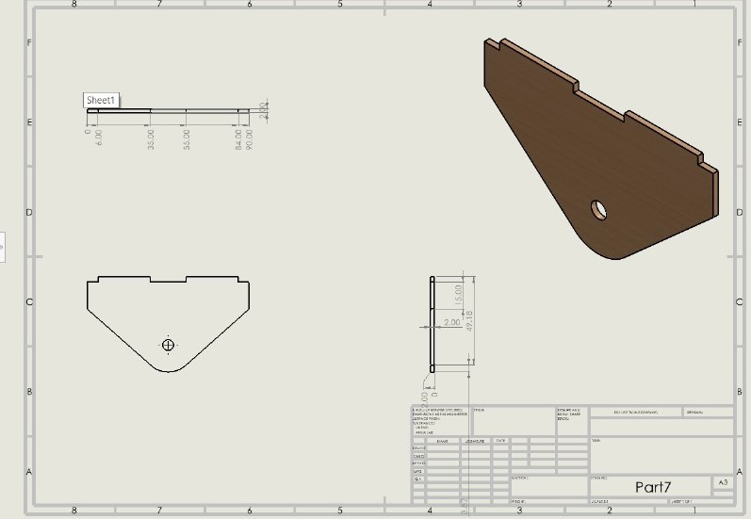

There is also 2 pieces of the part and it is installed on part 3.

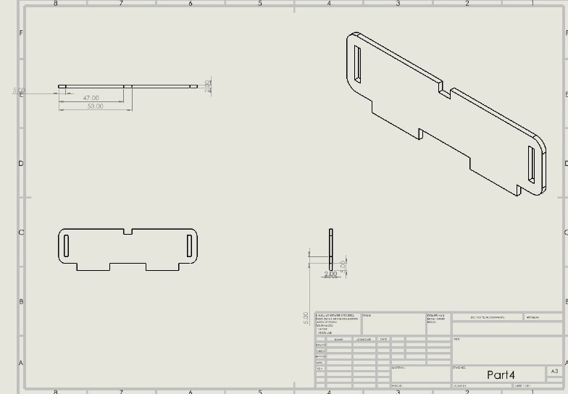 Figure 9.path part 6

We will use 2 pieces of this part and we will install them to part 2 .

Figure 10.path part 7

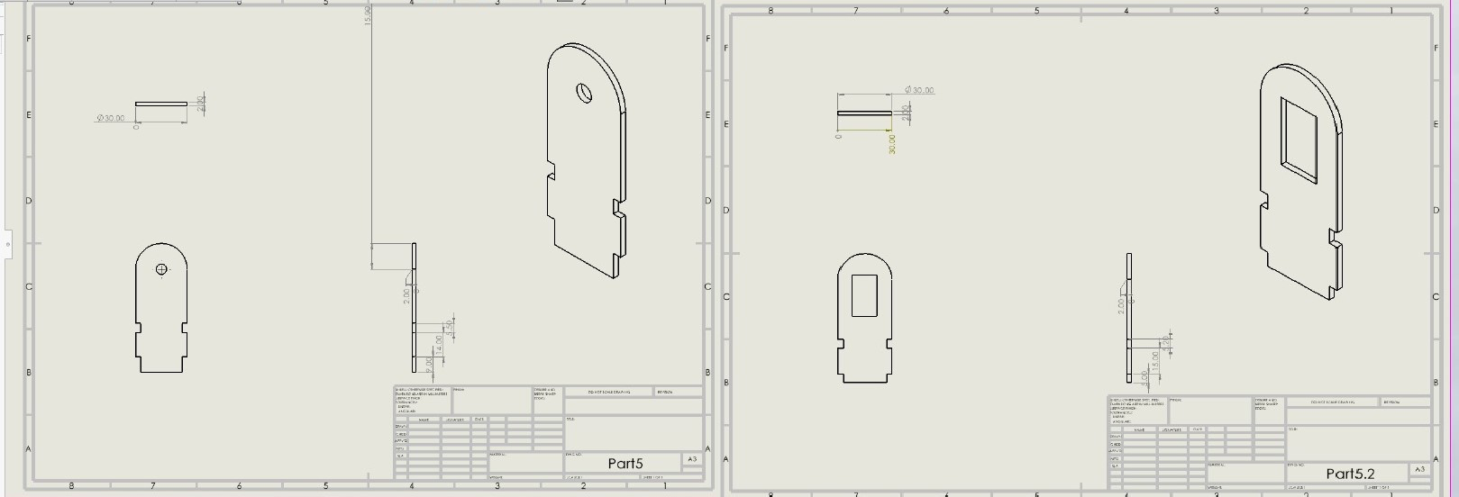

Part 5 is connected with part 4 and part 7 .

Part 5.2 is connected with part 4 also and we installed another servo motor to connect between this part and part 7 to move the part up and down .

Figure 11 path part 8

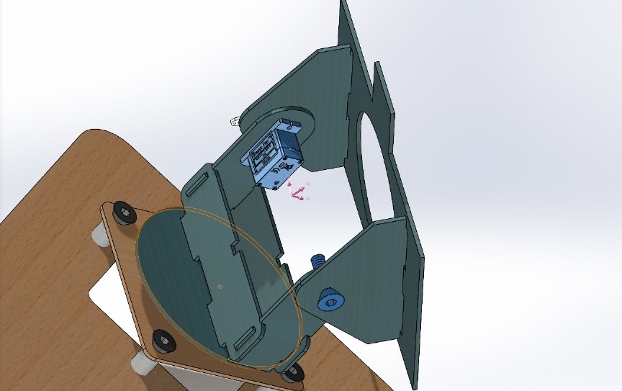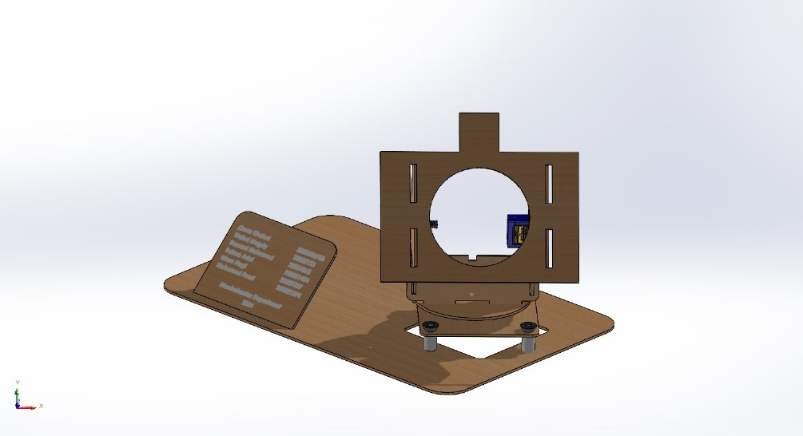

This is the final shape after we connected all the parts together.

* **Mathmatical :**

**Determining the Motor Drive Mechanism**

The first step is determining the [motor drive](https://eepower.com/technical-articles/motor-drive-applications/) mechanism. The drive mechanism includes a belt drive, shaft, direct rotation, pulley, ball screw or rack, and pinion.

In this design it is direct rotation.

-The next step is determining the motor’s parameters and specifications, including:

* Operating time and speed.
* Positioning distance and time.
* Resolution.
* Stopping accuracy.
* Voltage and power supply.
* Position holding.
* Environment of operation.
* Specific requirements and features like closed loop, open loop, feedback, programmable, agent approval, and IP rating.

To determine motor performance, establish the following three factors:

* Moment of inertia.
* Motor torque.
* Motor Power.

Once the above three factors are calculated, the motor will be selected depending on the values obtained for speed, inertia, and torque. A range of motors exists to choose from, such as servo .

**Sizing the Motor: Calculations**

For successful motor sizing, three important factors must be determined: [torque, inertia, and speed](https://eepower.com/market-insights/power-electronics-and-power-systems-the-importance-of-power-engineering-and-power-electronics/).

**Determining the Moment of Inertia**

Moment of inertia is the measure of any given object’s resistance to its rotation rate changes. An object at rest has a zero moment of inertia.

Trying to move an object focuses on changing its speed from point zero to any level. This is accompanied by the change in the moment of inertia.

**Rotating Object Moment of Inertia Calculation**

J = mL2

Where:

m = mass

L = The distance between the center of rotation and the center of gravity.

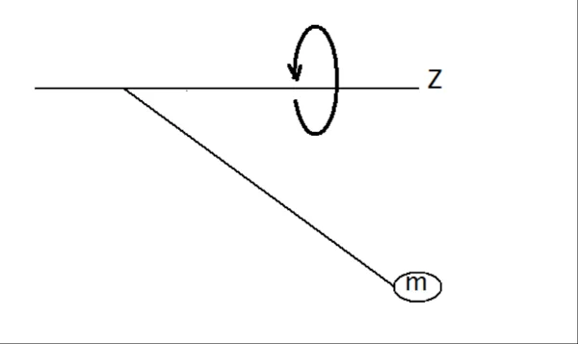

Figure 12 . The distance between the center of rotation and the center of gravity

Figure 13.

Total inertia seen by the motor 1 shaft:

𝐽𝑡𝑜𝑡𝑎𝑙= 𝐽𝑚 + (coupling)+ 𝐽𝑟𝑒f

Where 𝐽𝑟𝑒𝑓 = 𝐽𝐿/ 𝑖 2 ϻ

In the first calculate the total inertia (coupling, load).

𝐽𝑐𝑜𝑢𝑝𝑙𝑖𝑛𝑔 = 𝜋 𝜌 𝐿 (𝐷𝑜 4 − 𝐷𝑖 4)/ 32

For coupling:

𝜌=1420 kg/m^3, D(in)=0.5 cm , D(outer)=1.6 cm , Length =0.5 cm

So,

J(coupling)=4.52*10^-8 Kg.m^3

Jm

* Upper motor sizing
* Assume the angular velocity = 10.5 rad/sec

Number of revolution =100 r.p.m

Angular acceleration = w2r = 27.5 rad/sec2

Coupling outer diameter = 1.6 cm

Inner diameter = 0.5 cm

Tload = Jload * Smax = Tacc

Total mass =0.098 kg = 0.1 kg

Center mass = 0.0361 m

Jbad = 0.0005 kg .m2

The total inertia =Jm + Jcoupling +Jref

Jref =Jload =5*10-4 kg.m2

Jcoupling =[Π.P.L.(D4 -D4)]/32 = [Π*(1420)(0.5*10-2 )(11.6*10-2 )4-(0.5*10-2)4]/32

Jr=(Jref+Jcoup)/Jm = 4

Jm=1.25*10-4

Jtotal = 1.25*10-4 + 5*10-4 +4.5*10-8=6.25*10-4

Tacc= Tref= F.r = (m2.g)r =0.1 *9.8*(0.25*10-2)=2.45*10-3 N.m

T=( 2/iη)*(Jref .Smax +Tr)

Tref=μ.mg.r = μ.f .r

=0.3 * (0.1)*9.8*0.25*10-2 = 7.35*10-4 N.m

T=( 2/iη)*(Jref .Smax +Tr) = (2/0.9)*(15.0045*10-4*27.5)+0.0735*10-2)

=0.0322 N.m

T=( 2/iη)*(Jref .Smax +Tr)

=2/0.9 *[(5.004*10-4*27.5)+(7.35*10-4)]*10.5 = 0.34

The motor selected has torque =0.176 N.m

Tm= (Tload +T acc)* sF

0.176=(0.0137+ 2.45*10-3)*Sf

Sf= 10.89

The system is safe

Note the motor that has been selected is the smallest motor in the market

* Lower moter :
* Assume the angular velocity = 10.47 rad/sec

Number of revolution =100 r.p.m = 1.67rev/sec

Radius of the motor gear or coupling = 0.25 cm

α=w2.r =(10.47)2 (0.25) = 27.4 rad/sec2

The total inertia =Jm + Jcoupling +Jref

Jcoupling =[Π.P.L.(D4 -D4)]/32= [π(1450)(0.5*10-2)*(1.6*10-2)4-(0.5*10-2)4]/32 = 4.52*10-8 kg.m2

Jref = Jload = 6.5*10-4 kg.m2 (from solid work)

Tload = Jload * Smax = Tacc =6.5*10-4 *27.4= 0.0178 =0.02 N.m

Tref= F.r = (m2.g)r

Where r IS radius of shaft of motor

Tref= 0.139*9.8 *0.25 *10-2 = 3.4 *10-3N.m

Assume inertia ratio = 4

Jr=(Jref+Jcoup)/Jm = 4

Jm=1.625*10-4 kg.m2

Transmission efficiency = 0.9

Transmission ratio =1

T=( 2/iη)*(Jref .Smax +Tr)

(2/0.9)*(0.02 + 0.0034) = 0.052 N.m

Po=( 2/iη)*(Jref .Smax +Tr)*Wmax = 2/0.9 *(0.02 +0.0034)*10.5=0.6 watt

Number of revoluation = π.n/30

N=100 rpm

Safty factor (sf)

Tm= (Tload +T acc)* sF

Tm=0.176 N.m

S.F = 2

This motor is the smallest torque in the market

Figure 12.rotion around Z

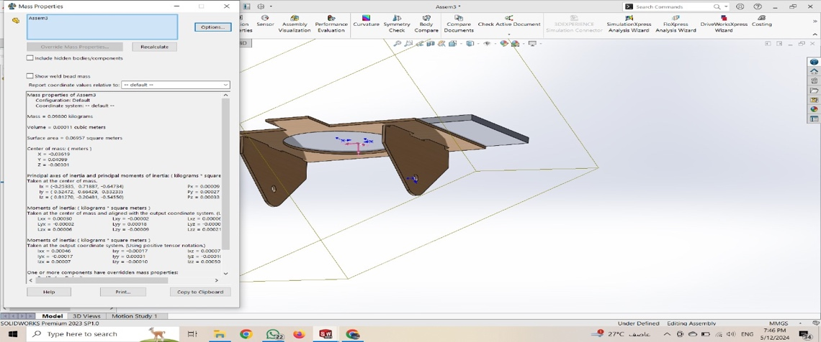

# 3.2.2Calculation of solar system

## Step 1 : Load Arduino uno

## Step 2 : Battery size selection in AH

## Step 3 : solar panel selection

### Step1: Load Arduino uno selection

I=100mA

Load volt =5V

Total load power for Arduino

P = V*I

P= 0.1 x 5 = 0.5 W

### Step 2 : Battery size selection in AH

Formula = $\frac{W x H}{v}$

W - total load power

H - Back up time in hours

V - battery voltage

**size = $\frac{0.5 x 8}{3.7}$ =1.08Ah**

Battery standard =1.3AH

Battery select =1.3AH

### Battery charging current

We will calculate charging current for 1.3AH battery.

As we know that charging current should be 10%of the AH rating of battery.

Therefore,

charging current for 1.3AH Battery

**1.3x $\frac{10\%}{100}$ =0.13 A**

### Step3: solar plates current

= Battery charging current + Load current

**0.13+0.1=0.23A**

## Step 4 : Solar plates power

solar power = V x I

**= 6 x 0.23 = 1.38 W** **P**

## Chapter 4

##### 3.3.1 Electrical design :

The electrical circuit of solar tracking will be connected as shown below:

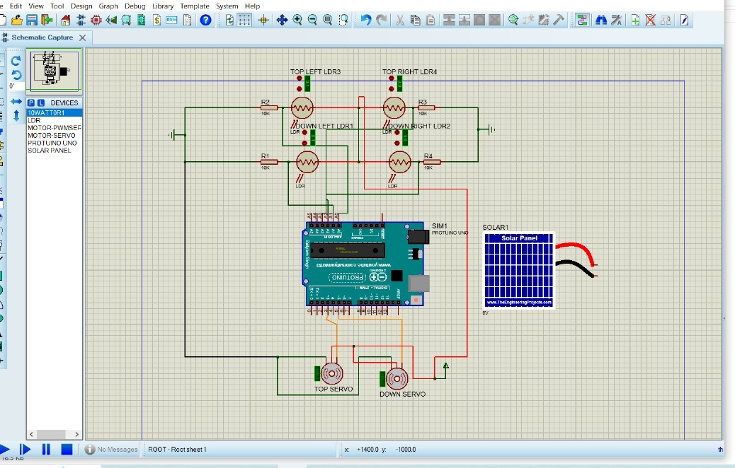

Figure 3.3.1 electrical circuit

* The +ve of (LDR 1) are connected by 5v power in Arduino
* The –ve of (LDR 1) are connected by two points first point is resistance 10K ohm then ground and second

point is pin A2 in Arduino

* The +ve of (LDR 2) are connected by 5v power in Arduino
* The –ve of (LDR 2) are connected by two points first point is resistance 10K ohm then ground and second

point is pin A3 in Arduino

* The +ve of (LDR 3) are connected by 5v power in Arduino
* The –ve of (LDR 3) are connected by two points first point is resistance 10K ohm then ground and second

point is pin A0 in Arduino

* The +ve of (LDR 4) are connected by 5v power in Arduino
* The –ve of (LDR 4) are connected by two points first point is resistance 10K ohm then ground and second

point is pin A1 in Arduino

* The servo have three pins red positive 5V ,black ground and orange signal
* The top servo is connected by pin 3 in Arduino
* The down servo is connected by pin 5 in Arduino

**5.1 FLOW CHART :**

# CHAPTER 5

- The following flow chart shows which the code for the project was created:

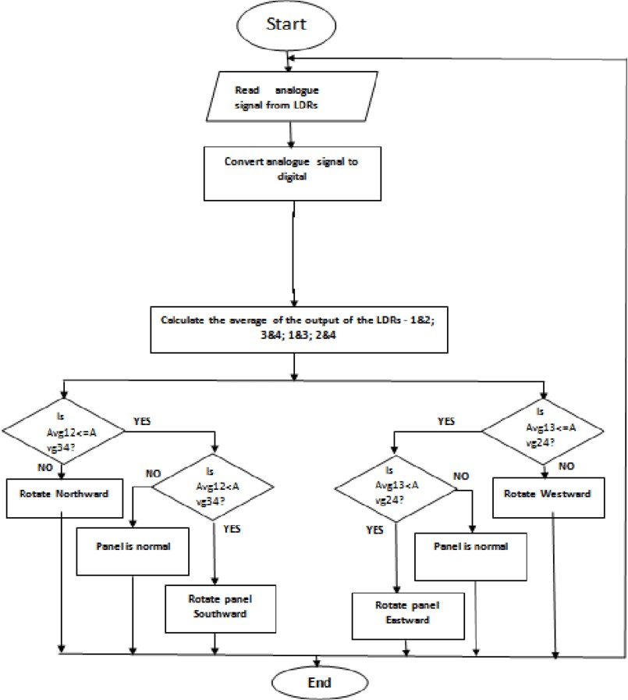

**5.2 Block Digram:**

sun LDR sensor

sensor signal

pv servo pulse signal plc

motor

6v

Lipo cv/cc battery 3.7 DC to DC

charger 3.7v converter

**3.4 simulink:**

**solarpanal**

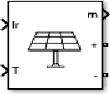

Figure 14 solarpanal

**Description:**

The PV Array block implements an array of photovoltaic (PV) modules. The array is built of strings of modules connected in parallel, each string consisting of modules connected in series. This block allows you to model preset PV modules The PV Array block is a five-parameter model using a light-generated current source (IL), diode, series resistance (Rs), and shunt resistance (Rsh) to represent the irradiance- and temperature-dependent I-V characteristics of the modules.

Figure 15

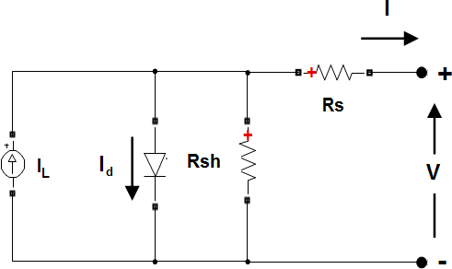

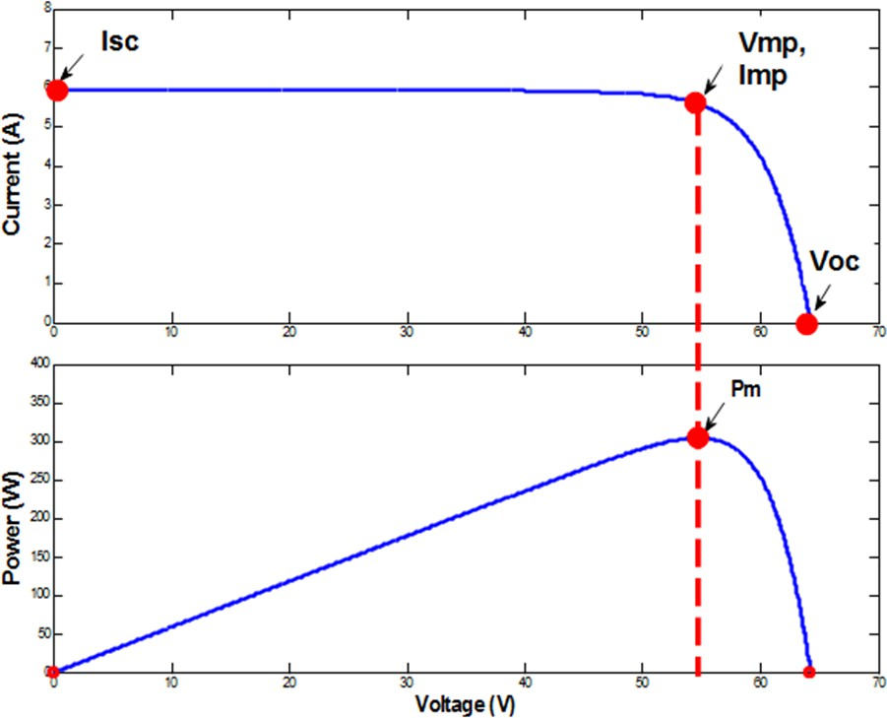

##### Input:

**Ir —** Control signal defining Irradiance applied to solar panels, W/m2 scalar in the range [0, 1000]

**T —** Control signal defining temperature of cells, degrees Celsius scalar

Control signal defining temperature of cells, specified as a scalar, in degrees Celsius. The input can be a finite negative, zero, or positive value.

**Output:**

**m —** Measurements five-element vector

**+** Positive terminal

**-** Negative terminal

**Battery**

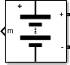

##### Description:

The Battery block implements a generic dynamic model that represents most popular types of rechargeable batteries**.**

**Input:**

Input port for the ambient temperature**. Output:**

m — Battery temperature, state-of-charge, current, voltage, age, maximum capacity, and ambient temperature

**Conserving:**

+ — Positive terminal

- — Negative terminal

**Bus selector**



##### Description:

The Bus Selector block extracts the elements you select by name from the input bus hierarchy. The block can output the selected elements separately or in a new virtual bus. When the block outputs the selected elements separately, each selected element corresponds to an output port. When the block outputs a new virtual bus, the block has one output port for the virtual bus that contains each selected element.

**Input:**

The input virtual or nonvirtual bus contains the elements to be selected.

**Output:**

By default, the block outputs each of the selected elements from a separate output port that is labeled with the corresponding bus element name

**RLC**



##### Description:

The Series RLC Branch block implements a single resistor, inductor, or capacitor, or a series combination of these

##### Mosfet



**Description**

The IGBT/Diode block is a simplified mode of an IGBT (or GTO or MOSFET)/Diode pair where the forward voltages of the forced-commutated device and diode are ignored.he IGBT block implements a semiconductor device controllable by the gate signal. The IGBT is simulated as a series combination of a resistor Ron, inductor Lon, and a DC voltage source Vf in series with a switch controlled by a logical signal (g > 0 or g = 0).

The IGBT turns on when the collector-emitter voltage is positive and greater than Vf and a positive signal is applied at the gate input (g > 0). It turns off when the collector-emitter voltage is positive and a 0 signal is applied at the gate input (g = 0).

The IGBT device is in the off state when the collector-emitter voltage is negative. Note that many commercial IGBTs do not have the reverse blocking capability. Therefore, they are usually used with an antiparallel diode.

The IGBT block contains a series Rs-Cs snubber circuit, which is connected in parallel with the IGBT device (between terminals C and E).

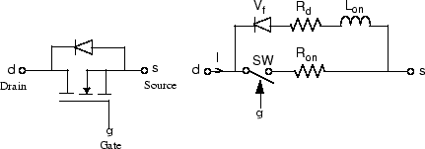

##### Input:

G-Simulink signal to control the opening and closing of the IGBT

##### Output:

m — Measurement vector

Simulink output of the block is a vector containing 2 signals. You can demultiplex these signals by using the Bus Selector block provided in the Simulink library.

**Conserving:**

D — Drain S — Source

Diode



##### Description:

The diode is a semiconductor device that is controlled by its own voltage Vak and current Iak. When a diode is forward biased (Vak > 0), it starts to conduct with a small forward voltage Vf across it. It turns off when the current flow into the device becomes 0. When the diode is reverse biased (Vak < 0), it stays in the off state

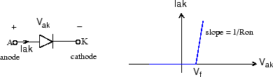

##### Conserving:

**a —** Anode specialized electrical

Specialized electrical conserving port associated with the anode.

**k —** Cathode specialized electrical

Specialized electrical conserving port associated with the cathode

**Output:**

M- Measurement vector containing two signals.

|  |  |  |
| --- | --- | --- |
| **Signal** | **Definition** | **Units** |
| 1 | Diode current | A |
| 2 | Diode voltage | V |

**Pulse Generator**



##### Description:

The Pulse Generator block generates square wave pulses at regular intervals. The block waveform parameters, **Amplitude**, **Pulse Width**, **Period**, and **Phase delay**, determine the shape

of the output waveform. The following diagram shows how each parameter affects the waveform.

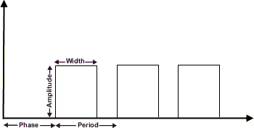

The Pulse Generator block can emit scalar, vector, or matrix signals of any real data type. To emit a scalar signal, use scalars to specify the waveform parameters. To emit a vector or matrix signal, use vectors or matrices, respectively, to specify the waveform parameters. Each element of the waveform parameters affects the corresponding element of the output signal. For example, the first element of a vector amplitude parameter determines the amplitude of the first element of a vector output pulse. All the waveform parameters must have the same dimensions after scalar expansion. The data type of the output is the same as the data type of the Amplitude parameter.

The block output can be generated in time-based or sample-based modes, determined by the Pulse type parameter.

**Output:**

**Port_1 —** Output signal

Generated square wave pulse signal specified by the parameter

**Voltage Measurement**



##### Description:

The Voltage Measurement block measures the instantaneous voltage between two electric nodes.

##### Output:

Outputs the instantaneous voltage measured between the + and - conserving ports, specified as a scalar

##### Conserving:

**+ —** Positive terminal

Specialized electrical conserving port associated with the positive terminal of the Voltage Measurement block.

**- —** Negative terminal specialized electrical

Specialized electrical conserving port associated with the negative terminal of the Voltage Measurement block

**Powergui**



##### Description:

The powergui block allows you to choose one of these methods to solve your circuit:

Continuous, which uses a variable-step solver from Simulink®

Discretization of the electrical system for a solution at fixed time steps

Continuous or discrete phasor solution

The powergui block also opens tools for steady-state and simulation results analysis and for advanced parameter design.

You need the powergui block to simulate any Simulink model containing Simscape™ Electrical™ Specialized Power Systems blocks. It stores the equivalent Simulink circuit that represents the state-space equations of the model.

When using one powergui block in a model:

Place the powergui block in the top-level diagram for optimal performance.

Make sure that the block is named powergui.

##### Scope

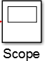

**Description:**

scopes provide several methods for displaying simulation data and capturing the data for later analysis. Symbols on your block diagram represent the various data display and data capture methods.

##### Display



**Description:**

The Display block shows the value of the input data. You can specify the frequency of the display. For numeric input data, you can also specify the format of display.

If the block input is an array, you can resize the block vertically or horizontally to show more than just the first element. If the block input is a vector, the block sequentially adds display fields from left to right and top to bottom. The block displays as many values as possible. A black triangle indicates that the block is not displaying all input array elements.

The Display block shows the first 200 elements of a vector signal and the first 20 rows and 10 columns of a matrix signal.

##### Analog Input



**Description:**

The Analog Input block opens, initializes, configures, and controls an analog data acquisition device. The opening, initialization, and configuration of the device occur once at the start of the model execution. During the model run time, the block acquires data either synchronously (deliver the current block of data the device is providing) or asynchronously (stream buffered incoming data).

The block has no input ports. It has one or more output ports, depending on the configuration you choose in its dialog box.

Use the Analog Input block to incorporate live measured data into Simulink® for:

System characterization

Algorithm verification

System and algorithm modeling

Model and design validation

Controller design

The following diagram shows the basic analog input usage configuration, with which you can:

Read acquired data at each time step or once per model execution.

Analyze the data, or use it as input to a system in the model.

Optionally display results.

##### Gain



Description:The Gain block multiplies the input by a constant value (gain). The input and the gain can each be a scalar, vector, or matrix.

You specify the value of gain in the Gain parameter. The Multiplication parameter lets you specify element-wise or matrix multiplication. For matrix multiplication, this parameter also lets you indicate the order of the multiplicands.

The gain is converted from doubles to the data type specified in the block mask offline using round-to-nearest and saturation. The input and gain are then multiplied, and the result is converted to the output data type using the specified rounding and overflow modes.

##### Solar panal in Matlab

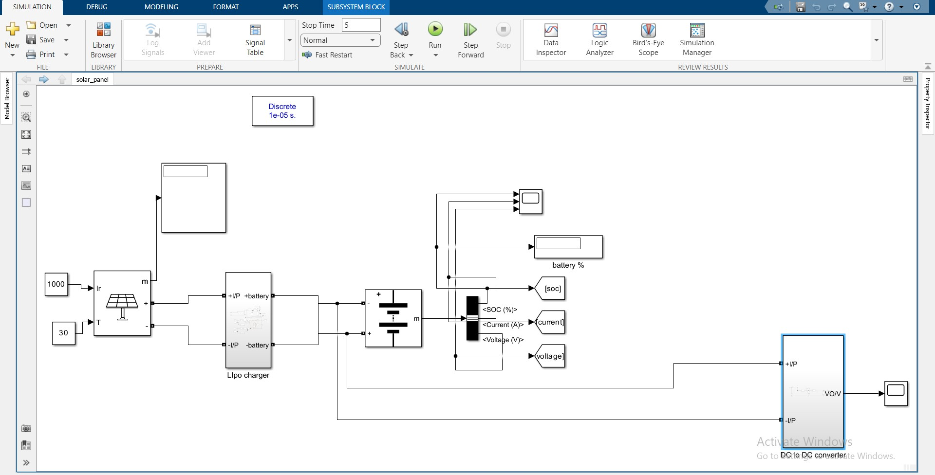

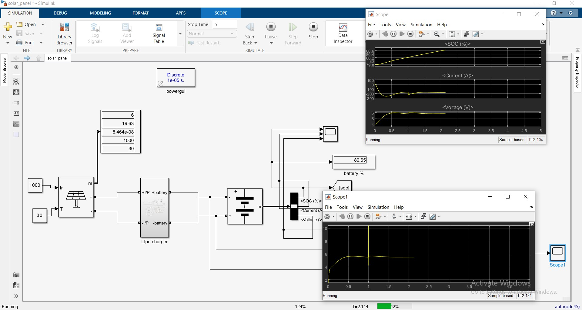

**Lipo Charger**

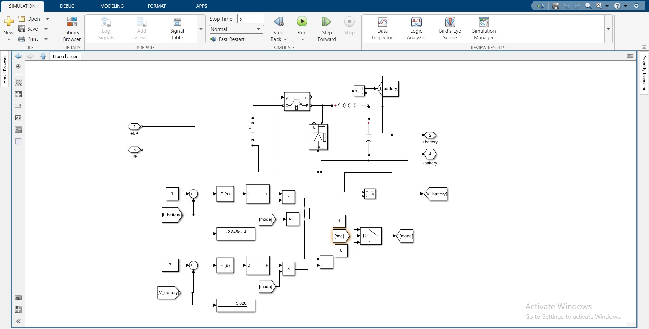

**DC to DC Converter**

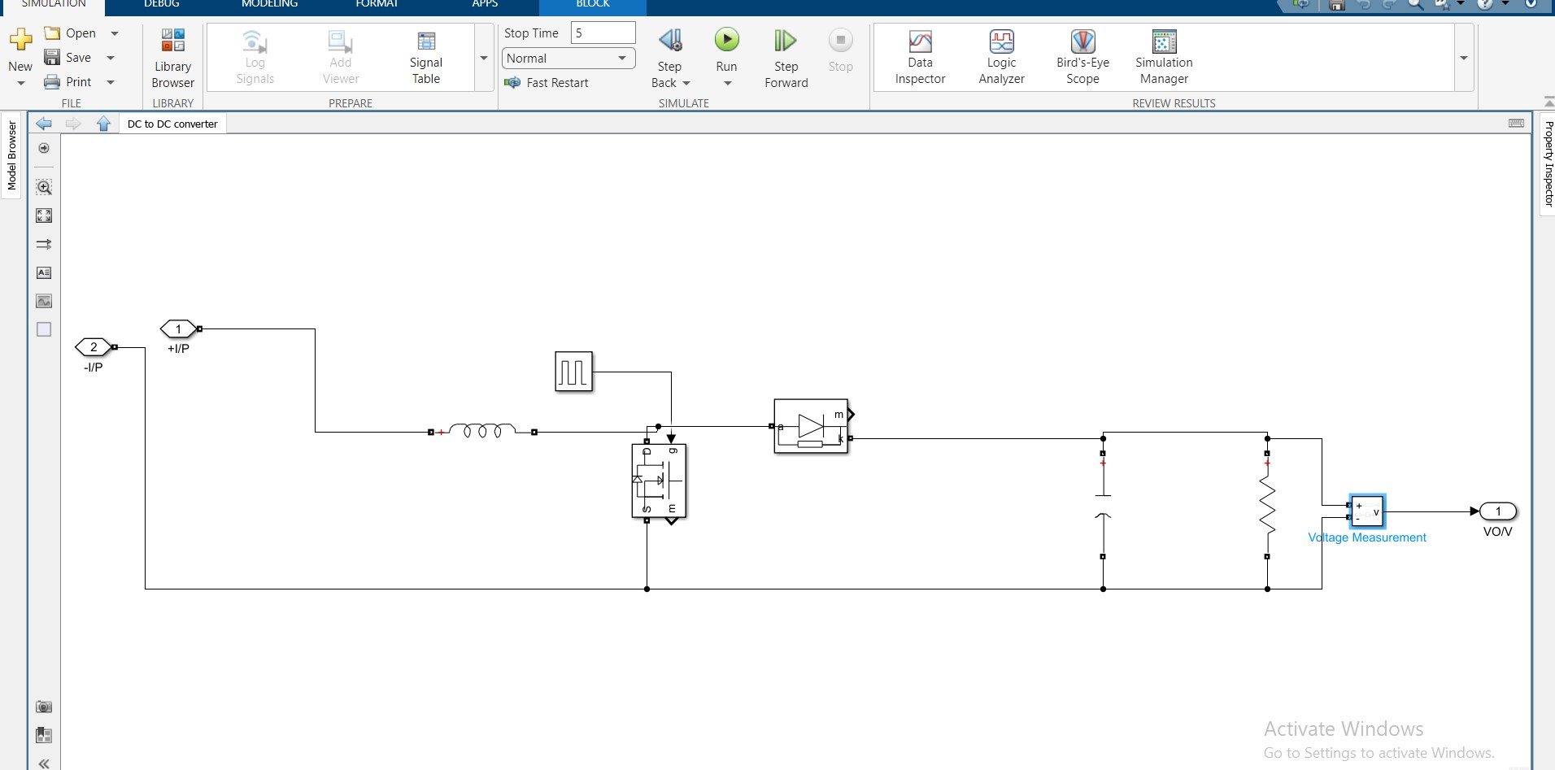

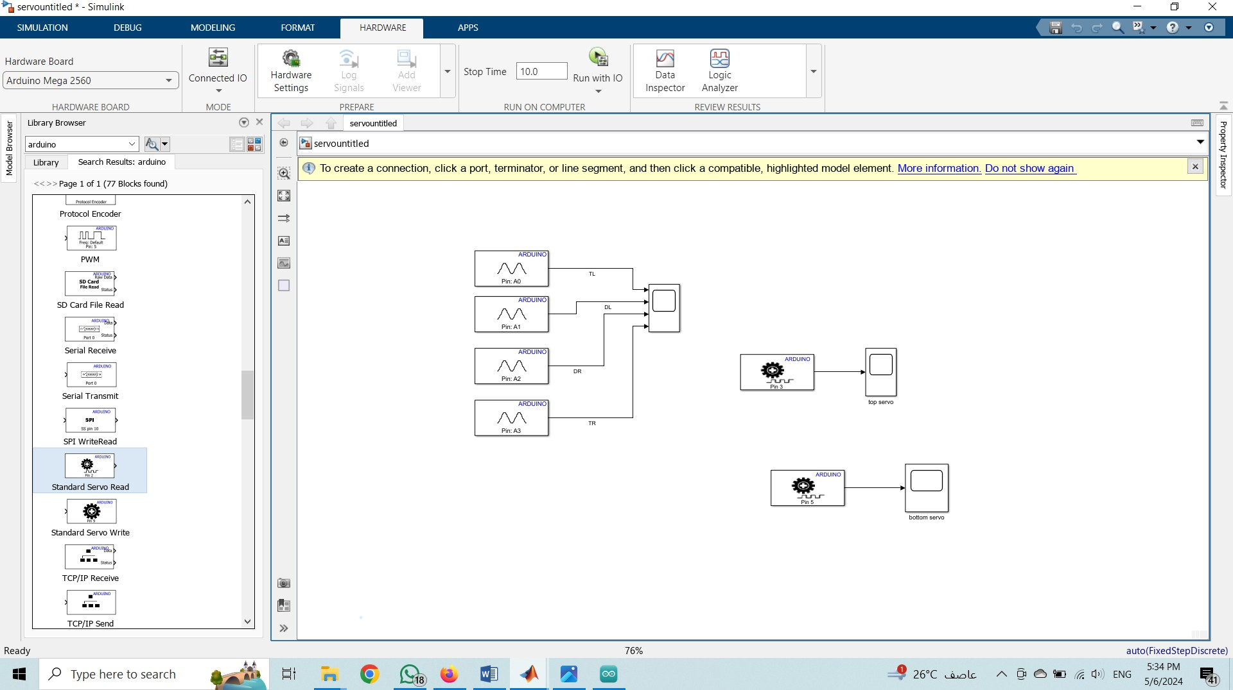

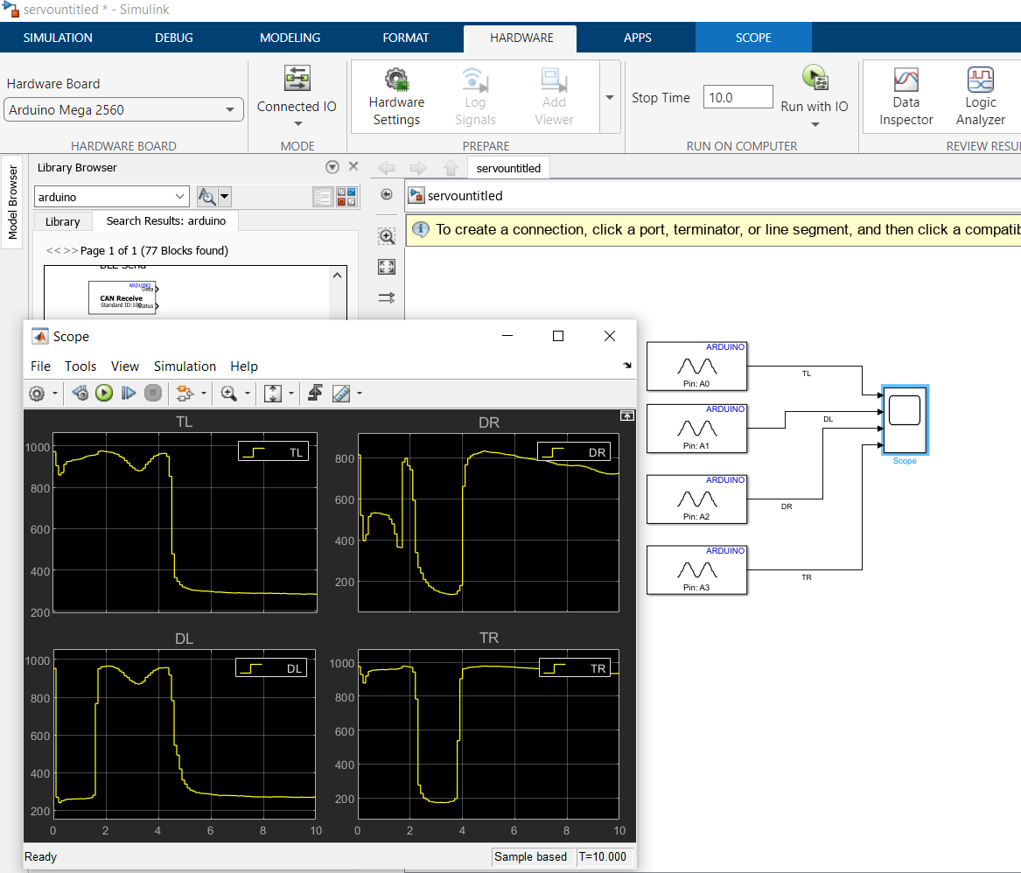

Top servo

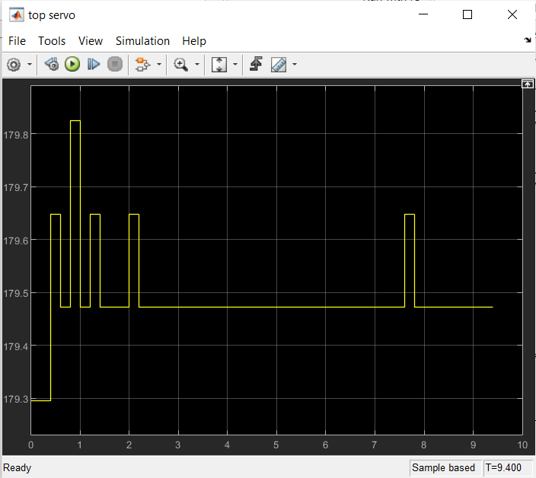

Bottom servo

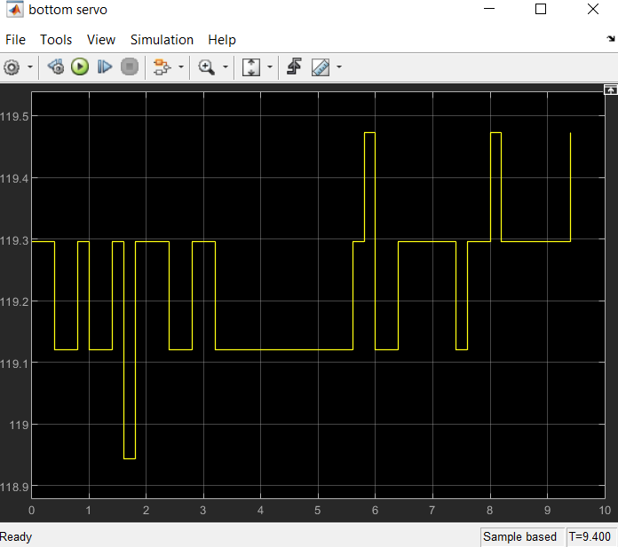

**Chapter.6**

6.1Advantages And Disadvanates

**Advantages of a Solar Tracking :**

1. Increased Energy Efficiency: Solar tracking systems can significantly increase the energy output of solar panels by ensuring they are always facing the sun. This results in higher energy generation and improved system efficiency.
2. Enhanced Performance: Solar tracking systems allow solar panels to capture sunlight at optimal angles throughout the day, maximizing energy production and overall system performance.
3. Improved Return on Investment: By increasing energy generation, solar tracking systems can potentially lead to quicker payback periods and enhanced return on investment for solar power projects.
4. Environmental Benefits: Solar tracking systems help to reduce the carbon footprint of solar power systems by maximizing energy production from renewable sources, contributing to a cleaner and more sustainable environment.
5. Suitable for Challenging Locations: Solar tracking systems are particularly beneficial in locations with varying sunlight angles or during seasons with lower solar exposure, ensuring consistent energy production regardless of environmental conditions.

**Disadvantages of a Solar Tracking :**

1. Cost: Solar tracking systems are more complex and expensive compared to fixed solar panel installations, requiring additional components such as sensors, motors, and controllers. This can increase the initial cost of the solar power system.
2. Maintenance: Solar tracking systems may require more frequent maintenance and monitoring to ensure proper functioning of the tracking mechanism, sensors, and motors. This can add to the operational costs and complexity of the system.
3. Reliability: Depending on the design and quality of components, solar tracking systems may be susceptible to mechanical failures or malfunctions, leading to downtime and potentially impacting energy generation.
4. Installation Complexity: Installing a solar tracking system can be more complex than a fixed mounting system, requiring precise alignment, calibration, and configuration of tracking mechanisms. This may require additional expertise during installation.
5. Energy Consumption: Some solar tracking systems require additional energy to operate the tracking mechanisms, which can partially offset the energy gains from improved solar panel orientation. This additional energy consumption could impact the overall efficiency of the system.

CHAPTER: 6

SCOPE OF IMPROVEMENT

**6.1: Future Work and Recommendations**

The goals of this project were purposely kept within what was believed to be attainable within the allotted timeline and resources. As such, many improvements can be made upon this initial design. That being said, it is felt that this design represents a functioning miniature scale model which could be replicated to a much larger scale. The following recommendations are provided as ideas for future expansion of this project:

Remedy the motor binding problems due to the photo sensor leads. This could be done with some use of easy to bend

cables which don't necessarily exert any force on the motor when it is turning the solar panel. Alternatively, a smaller gauge wire, a larger motor with more torque, or a combination of some or all of these ideas. Increase the sensitivity and

accuracy of tracking by using a different light sensor. A photo transistor with an amplification circuit would provide improved resolution and a better tracking accuracy/precision. Use of components used. Utilize a dual- axis design versus a

single-axis to increase tracking accuracy. Future solar project should use a microcontroller which can be used as a standalone unit in the fabricated circuit without the use of the programmer kit

CHPATER: 8

## REFERENCES

[1] A.K. Saxena and V. Dutta, "A versatile microprocessor based controller for solar tracking," in Proc. IEEE, 1990, pp. 1105-1109.

[2] T.A. Papalias and M. Wong, "Making sense of light sensors," http://www.embedded.com, 2006.

[3] R. Condit and D. W. Jones, "Simple DC motor fundamentals," Texas Instruments. Publication AN907, pp. 1-22, 2004.

[4] Texas Instruments., "MSP430G2553 Datasheet," www.ti.com, 2001

[5] "Fabrication of Dual-Axis Solar Tracking Controller Project", Nader Barsoum, Curtin University, Sarawak, Malaysia, Intelligent Control and Automation, 2011, 2, 57-68.

## ABBREVIATIONS AND ACRONYMS

ADC Analog to Digital Converter

EEPROM Electrical Erasable programmable Read Only Memory

D Diode

DC Direct current

GND Ground

I Current

l/0 Input/ Output

IDE Integrated Development Environment

LDR Light Dependent Resistor

LED Light Emitting Diode

LUX Luminous Flux

LED   Light Emitting Diode

MAX Maximum

MCU Microcontroller

MIN Minimum

VCC Supply voltage

UV Ultra Violet Light

PCB Printed Circuit Board

PV Photovoltaic panels

R Resistor

GaAs gallium arsenide

**Conclusion**

The current paper deals with the design and execution of a solar tracker system dedicated to the PV conversion

panels. The operation of the experimental model of the device is based on a servo motor and servo motor

intelligently controlled by a dedicated ATmega328 that moves a mini PV panel according to the signals received from

four simple light sensors. In order to collect the greatest amount of energy from the sun, solar panels must be aligned

orthogonally to the sun. For this purpose, a new solar tracking technique based on micro-controller ATmega328

was implemented and tested in this study. Moreover, the tracker can initialize the starting position itself which reduce

the need of any more photo resistors. The use of servo motor enables accurate tracking of the sun.LDR resistors

are used to determine the solar light intensity. Suntracking generating power system is designed and implemented

in real time.

The proposed double axis solar tracker device ensures the optimization of the conversion of solar energy into

electricity by properly

orienting the PV panel in accordance with the real position of the

sun.The attractive feature of the designed solar tracker is simple and inexpensive mechanism to control the system.

It is also provides lucrative solution for third world countries. It is shown that the sun tracking system using

controller with ATmega328 achieves increasing of about 25% efficiency improvement over the fixed sun panel system.

#### Components:

1. **Arduino uno**
2. **Solar panel**
3. **Servo motor**
4. **Bread board**
5. **Jumpers**
6. **LDR sensor**
7. **Battery 3.7V**
8. **Battery holder cell**
9. **DC motor micro**
10. **DC to DC converter**
11. **Lipo battery charger**

#### Data sheet & discribe:

##### Arduino uno:

Microcontroller ATmega328

Operating Voltage 5V Input Voltage (recommended) 7-12V Input Voltage (limits) 6-20V

Digital I/O Pins 14 (of which 6 provide PWM output) Analog Input Pins 6

DC Current per I/O Pin 40 mA

DC Current for 3.3V Pin 50 mA

Flash Memory 32 KB (ATmega328) of which 0.5 KB used by bootloader

SRAM 2 KB (ATmega328)

EEPROM 1 KB (ATmega328)

Clock Speed 16 MHz

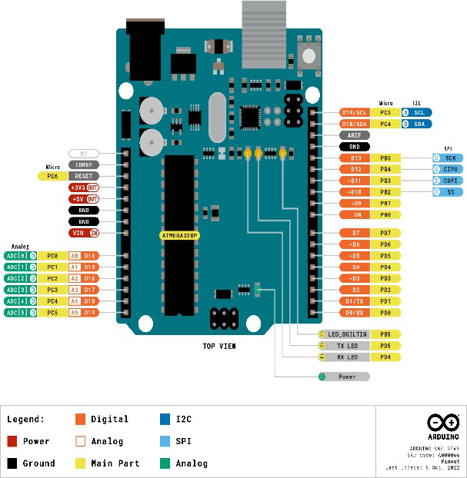

1. **Solar panel:**

These panels come to us from Voltaic Systems, makers of fine solar-powered bags and packs. These are waterproof

scratch resistant, and UV resistant. They use a high efficiency monocrystalline cell. They output 6V at 400 mA via 3.5mm x 1.1mm DC jack connector. The substrate is an aluminum / plastic composite, specifically designed

to be strong and lightweight. They can easily stand up to typical outdoor use including being dropped and

leaned on. They're very high quality and suggested for projects that will be exposed to the outdoors.

o Size: 181mm x 81mm

o Weight: 3 ounces / 90 grams

o Cell type: crystaline silcone

o Cell efficiency: 19%+

o 2.7 Watts Peak Power

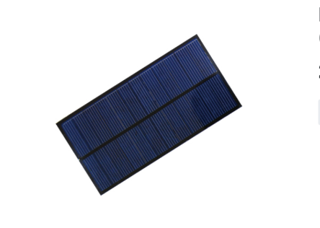

1. **Servo motor:**

**SG90 9 g Micro Servo**

Tiny and lightweight with high output power. Servo can rotate approximately

180 degrees (90 in each direction), and works just like the standard kinds but

smaller. You can use any servo code, hardware or library to control these

servos. Good for beginners who want to make stuff move without building a

motor controller with feedback & gear box, especially since it will fit in small

places. It comes with a 3 horns (arms) and hardware.

Specifications

• Weight: 9 g

• Dimension: 22.2 x 11.8 x 31 mm approx.

• Stall torque: 1.8 kgf·cm

• Operating speed: 0.1 s/60 degree

• Operating voltage: 4.8 V (~5V)

• Dead band width: 10 μs

• Temperature range: 0 ºC – 55 ºC

Position "0" (1.5 ms pulse) is middle, "90" (~2ms pulse) is all the way to the left.

ms pulse) is all the way to the right, ""-90" (~1ms pulse) is all the way to the

left

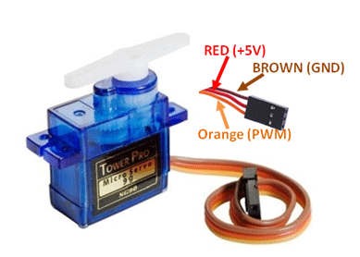

Fig 2.1 servo motor

# LDR sensor:

## 3.1: Light Sensor Theory and Circuit of Sensor Used :

-Light detecting sensor that maybe used to build solar tracker include; phototransistors, photodiodes, LDR and LLS05. A suitable, inexpensive, simple and easy to interface photo sensor is analog LDR which amongst the light sensors is the most common in electronics. It is usually in form of a photo resistor made of cadmium sulfide (CdS) or gallium arsenide (GaAs). Next in complexity is the photodiode followed by the phototransistor. The solar tracker in this project uses a cadmium sulfide (CdS) photocell for light sensing. This is the least expensive and least complex type of light sensor. The CdS photocell is a passive component whose resistance in inversely proportional to the amount of light intensity falling on it. To utilize the photocell, it is placed in series with a resistor (810K potentiometer in this case). A voltage divider is thus formed and the output at the junction is determined by the two resistances. Figure 1 illustrates the photocell circuit. In this project, it was desired for the output voltage to increase as the light intensity increases, so the photocell was placed in the top position as shown below.

## 3.1.1 Construction and Operation of an LDR:

- The cadmium sulfide (CdS) or light dependent resistor (LDR) whose resistance is inversely dependent on the amount of light falling on it, is known by many names including the photo resistor, photoresistor, photoconductor, photoconductive cell, or simply the photocell. A typical structure for a photoresistor uses an active semiconductor layer that is deposited on an insulating substrate. The semiconductor is normally lightly doped to enable it to have the required level of conductivity. Contacts are then placed either side of the exposed area. The photo- resistor, CdS, or LDR finds many uses as a low cost photo sensitive element and was used for many years in photographic light meters as well as in other applications such as smoke, flame and burglar detectors, card readers and lighting controls for street lamps [2]. Since this is

* + 1. Light Sensor Design

As presented in Chapter above, the sun tracker uses a CdS photocell for light detection. A complementary

resistor value of 10 KQ was used to construct the circuit shown in Figure above. In this configuration, the output voltage wil increase

as light intensity. The complementary resistor value should be chosen such as to achieve the widest output range 15 possible. Photocell resistance was measured under dark conditions, average light conditions, and bright light conditions. The results are listed in Table below

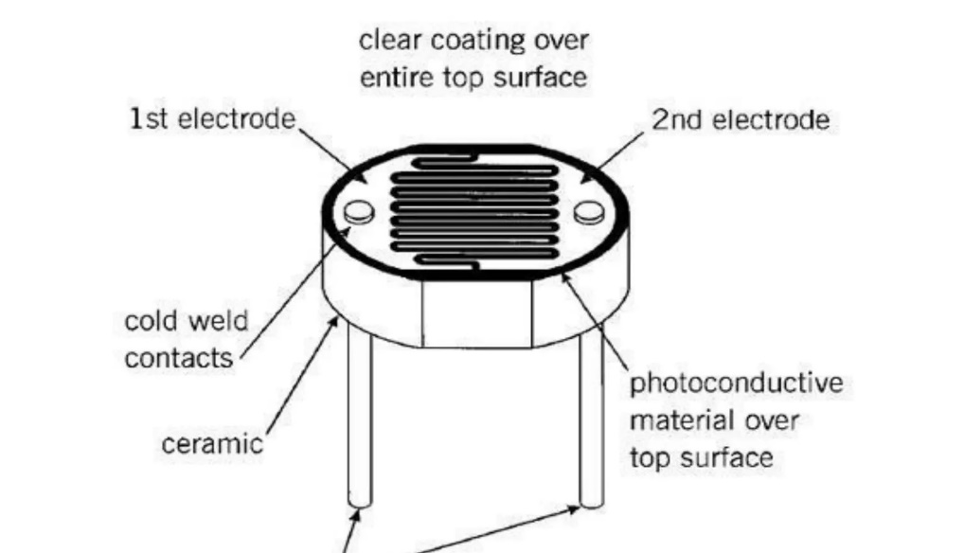

**Fig3.1**

##### Battery 3.7V:

Ultra fire lot ultrafire 18650 3.7v rechargeable battery 6800 mah- 2 pieces, red

1. **DC to DC converter:**

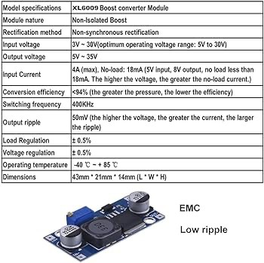

**Test sample reference**

* + Input 3V Output 12V 0.4A 4.8W
  + Input 5V Output 12V 0.8A 9.6W
  + Input 7.4V Output 12V 1.5A 18W
  + Input 12V Output 15V 2A 30W
  + Input 12V Output 16V 2A 32W
  + Input 12V Output 18V 1.6A 28.8W
  + Input 12V Output 19V 1.5A 28.5W
  + Input 12V Output 24V 1 A 24W

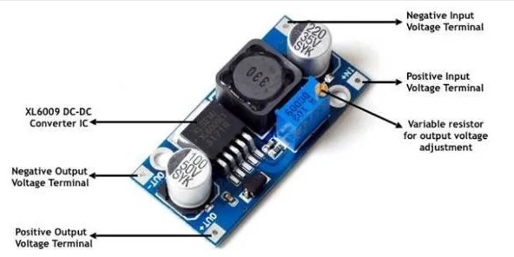

##### Lipo battery charger:

##### 

* + Programmable Charge Current Up to 1000mA
  + No MOSFET, Sense Resistor or Blocking Diode Required
  + Complete Linear Charger in SOP-8 Package for Single Cell Lithium-Ion Batteries Constant-Current/Constant-Voltage
  + Charges Single Cell Li-Ion Batteries Directly from USB Port
  + Preset 4.2V Charge Voltage with 1.5% Accuracy
  + Automatic Recharge
  + two Charge Status Output Pins
  + C/10 Charge Termination
  + 2.9V Trickle Charge Threshold (TP4056)
  + 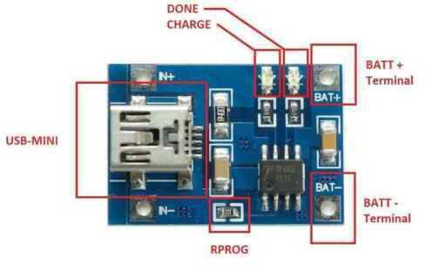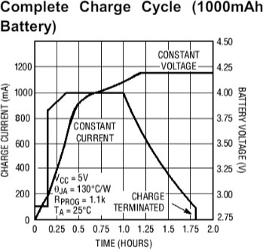Soft-Start Limits Inrush Current

Figure Figure

The following picture shows what the finished project looks like:

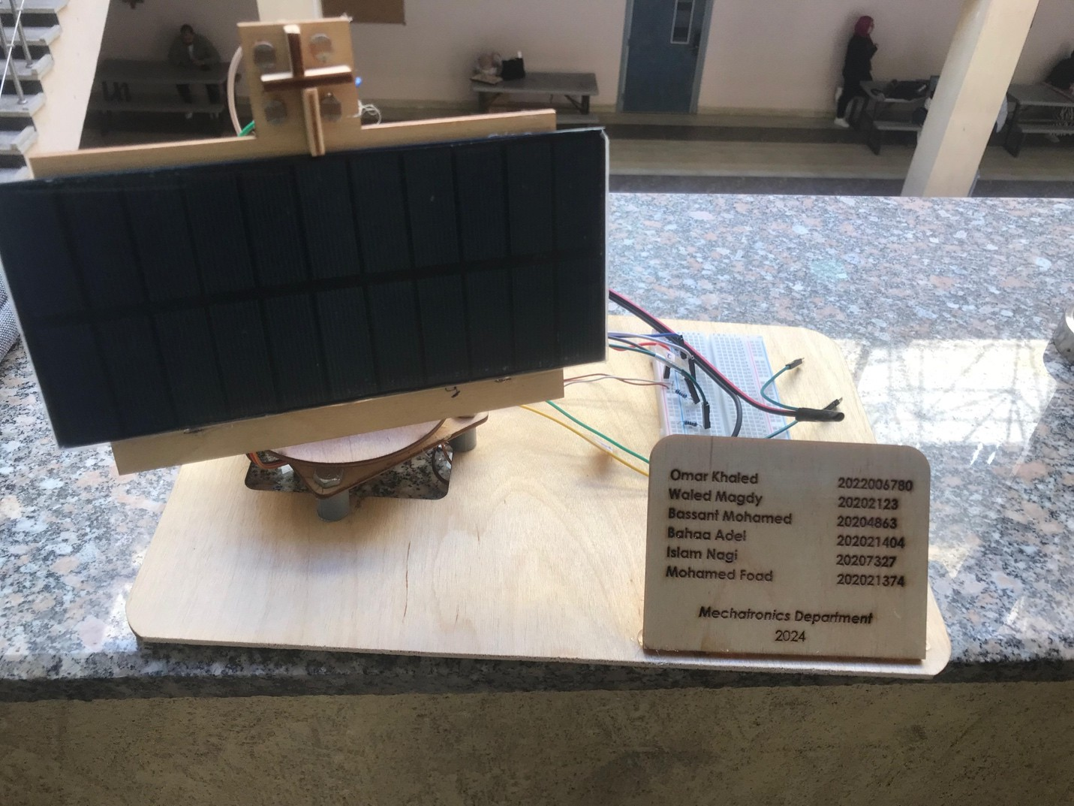

Figure 15 . end project